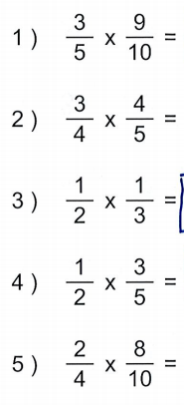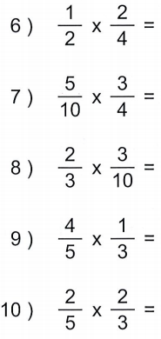

Word Problems
- A factory makes sheets of metal that are 2/5 of an inch thick. If a worker at the factory makes a stack of 2 of the sheets, how many inches thick will the stack be?

- Jake collected 3/8 of a bin of glass bottles to recycle. Leslie collected 3 times as many bins as Jake. How many bins of bottles did Leslie collect?

- A factory puts 2/3 of a gallon of vinegar into each batch of salad dressing. How many gallons of vinegar will be used in 9 batches?

- A cookie factory puts 1/2 of a barrel of flour into each batch of cookies. How much flour will the factory use for 8 batches?

- Harry operates a hot dog stand. On Wednesday he used 4 bags of hot dog buns. On Thursday he used 1/2 as many hot dog buns as on Wednesday. How many bags of hot dog buns did Harry use on Thursday?

