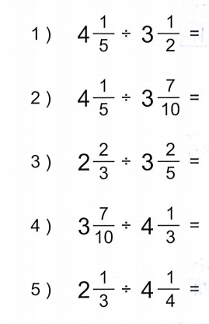
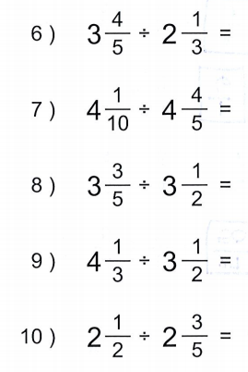1.

- Two children share 2 ½ chocolate bars with each child getting the same amount. How much does each child get? Solve with a drawing.

- Four brothers inherit 30 ½ acres of land altogether. They decide to share it equally. How much land does each brother get? Solve with a drawing.

- If it rained the same amount each day for 3 days and the total amount of rain received was 3 1/3 inches, how much did it rain each day?

- A rope that is ¾ in length is cut into 2 pieces of equal length. How long is each piece? Solve with a drawing.

- Four students are participating in a relay race that is 2 1/3 miles long. If each student runs that same distance, how far does each student run?

- Click and Clack decide to take a journey in their classic ’52 MG. The whole journey is 625 ½ miles long and they want to complete the journey in 3 days, traveling exactly the same distance each day. How far must they travel each day?

- Two pizzas are cut so that each person at a party receives ¼ pizza, how many people are at the party?

- Ten bananas were used for making pies for a bake sale. If 2 ½ bananas were used for each pie, how many pies were made?

