Name: ___________________________________

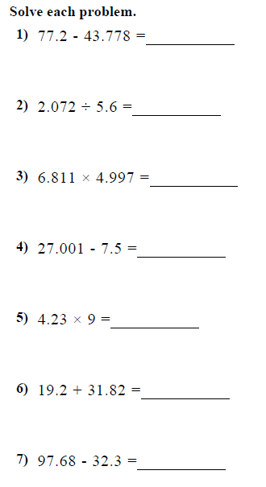

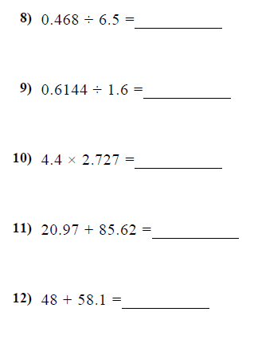

Multiplying and Dividing Decimals

